|  |
| --- |
| **How to create a MS SQL Server database using SQL Server 2008 R2** |
|  |
|  |
|  |
|  |
| **LinkBird Technologies** |
|  |
|  |

**Download and install Microsoft SQL server 2008 R2, if you don't have the version.**

**Step-1**

Please download Microsoft SQL Server 2008 R2

<https://www.microsoft.com/en-us/download/details.aspx?id=23650>

**Step-2**

Follow how to install Microsoft SQL Server 2008 R2 on your machine.

<https://www.youtube.com/watch?v=UaOwvsnL9Ps>

**Step-3**

Follow how create SQL Server database.

<https://www.youtube.com/watch?v=gyBT75-5lV4>

**How to import a script into SQL Server?**

* Open Microsoft SQL Server 2008 R2 [Run as administrator mode]
* Server Name: **(local)** , Authentication Mode : **Windows Authentication**

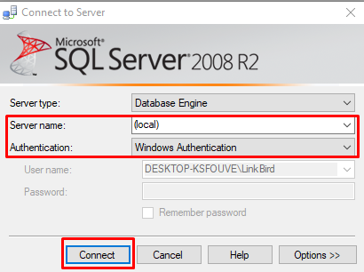

From the Object Explorer panel, Right click on Databases and click on New Database.

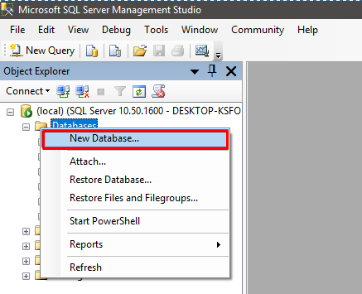

Enter Database name and click on OK button.

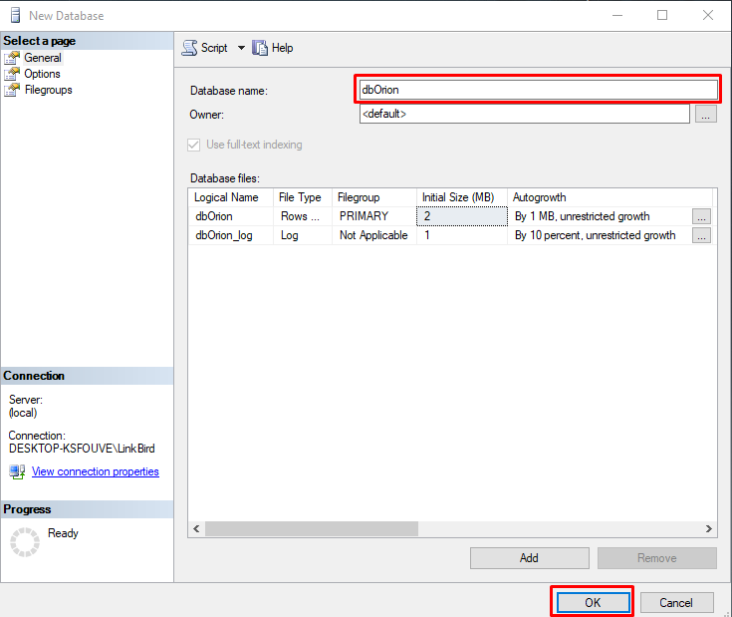

Click new query and Click on connect button

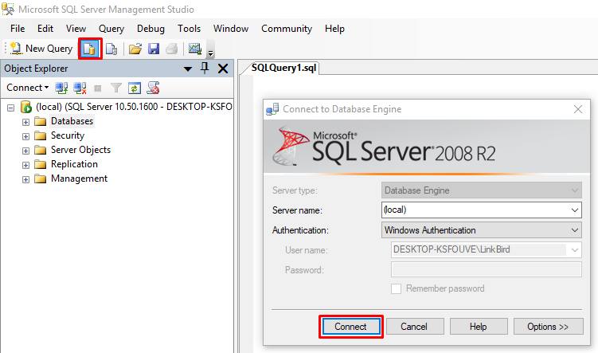

Open ms_sql_server_dborion.sql on notepad from **SQL Script** folder. Copy all script from ms_sql_server_dborion.sql and paste on sql server query window. And Click the Execute Button.

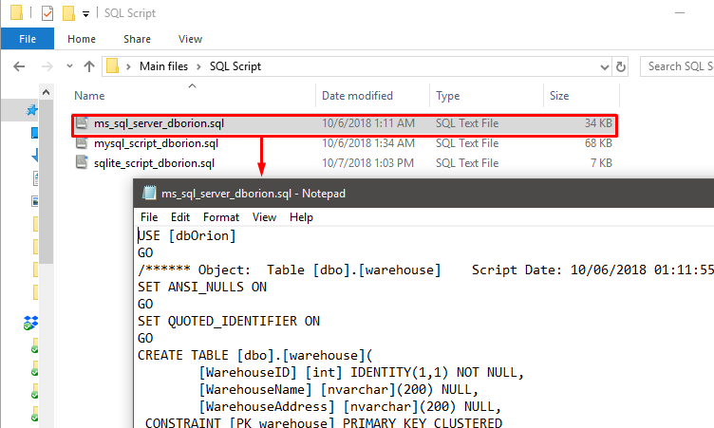

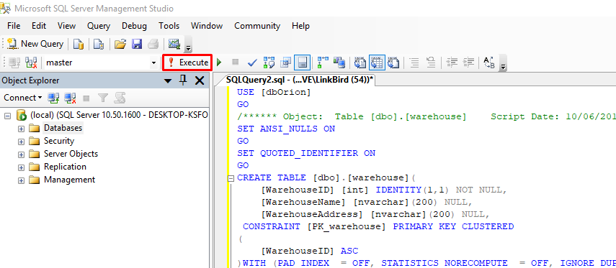

After successfully importing ms_sql_server_dborion.sql, Import has been successfully finished message will be shown. Left side of the database list, expand dbOrion. You can see all data table in this database.

